**Welcome to AP Art History!**

This course seeks to understand and analyze the history of the world through 250 works of art and architecture. Each work is unique and tells it’s own story about the people, places, and events that were going on at that specific moment in history. Although we do cover many different area, civilizations, religions, and people groups, we do not cover them all. We also do not have the opportunity to discuss some major artists, works of art, or styles of art and architecture, that have made an impact on the world of art and subsequently on art history.

This year’s summer assignment is going to be the same as last years. Normally, I would send you to the Princeton University Art Museum to experience art in person and to see many of the different styles and works of art that we would examine throughout the year (including an Aztec Sacrificial Stone…). Since, as of writing this on June 11th, 2022, the Princeton University Art Museum is under construction and remodeling until the end of the 2023 calendar year at the earliest. So, I am choosing to continue a summer assignment that you can complete at home and on your own time. We will still do the Princeton University Art Museum scavenger hunt at the end of the 2022/2023 school year!

We will start the year by examining a movement of art that is somewhat misunderstood and, if you are an artist who takes part in this movement, possibly even exploited and/or considered a criminal. **This year’s summer assignment will focus on introducing yourself to AP Art History through street art**. Although commonly referred to as “graffiti”, street art is so much more than just poorly planned names signed on train cars or haphazard murals quickly put up on public walls. Street art can take many forms (graffiti, mosaics, murals, yarn bombing, and much more!) and it often, if planned well enough and has a purpose, can actually improve local communities in multiple ways.

Below you will find more specific directions for your summer assignment. Please feel free to reach out to me ([clugo@mtsd.us](mailto:clugo@mtsd.us)) if you have any questions.

I look forward to meeting/working with you all come the fall and to introducing you to the expansive, interesting, and challenging world of Art History. **This class is a lot of work, and I have high expectations for students who sign up for the class, but it is an experience that makes you a better human being once you have completed the journey.** Learning about art and the history connected to it has changed my life and I know it will change yours, too.

Thanks for being a part of it and trying something new.

Best,

CL

This summer assignment predominantly focuses on videos, both long and short. Please watch them in order as they are layered in a way that builds on the previous video. Once you have completed watching all of the videos and the documentary, please be sure to read the directions on the next page and follow those directions.

**These are due BEFORE the first day of class.**

**MAKE SURE YOU ARE LOGGED OUT OF YOUR MTSD ACCOUNT TO WATCH THESE VIDEOS. Some of them may be restricted by your MTSD account regardless of you being on private Wi-Fi at home.**

**1.** [**Is graffiti Art? Or vandalism? - TED ED**](https://www.youtube.com/watch?v=4GNoUYZhrT0)

- This brief and animated history of street art asks a very important question about street art: Is it worth millions of dollars or is it a crime?

**2. [Why Philadelphia Has Thousands of Murals - VOX](https://www.youtube.com/watch?v=qu7cen0VOAA)**

- As mentioned above, street art and murals have an extensive and vivid history all around the world. Yet, it took us until 2010 to really begin to understand the value that murals have on the community, the health and wellness of that said community, and on the economy.

**3.** [**Use Art to Turn the World Inside Out - TED**](https://youtu.be/0PAy1zBtTbw)

- This TED talk, given by JR explains how he uses street art for good. His works are moving and he highlights the plight of many different people around the world. From the tough suburbs of Paris to the favelas of Brazil, streets of India, and beyond, JR uses art to raise awareness. Be sure to turn on Closed Captioning if you have a difficult time understanding his accent.

**4. [David Zinn: Street art that washes away in the rain - BBC News](https://www.youtube.com/watch?v=f885C3fD-u4&list=WL&index=26)**

- David Zinn is one of my favorite artists. Chalk is such an underappreciated medium and the way he channels this youthful core to create his fantastical works is something that always gets me. There are many videos on him, but I just wanted to share this short one to introduce you to another form of street art, albeit a little more transient than others. When I visited Ann Arbor, Michigan in the fall of 2022, you could find his art, and copy cats cloning his style, all over the college town. His creativity is something that is truly eye opening as it reminds us that, at one point, we were all artists, but most of us stop drawing and chasing that creativity.

**5. [Exit Through The Gift Shop - Documentary](https://www.youtube.com/watch?v=IqVXThss1z4)**

- This documentary follows the famous street artist, Banksy… or does it? This is the final piece of the summer assignment, so please enjoy this documentary. Many famous street artists make an appearance in this, so keep an eye out for any that interest you!

**LASTLY! I encourage you to go on YouTube and look up street art time-lapse videos or any artist that interested you. There are a ton of talented artists out there that work in various mediums for the public to see.**

**SUMMER ASSIGNMENT CHECKLIST:**

Please read all directions first before you begin your assignments.

**1. Exit Through the Gift Shop and Summer Assignment Questions**

- Please use the link below to find the Google Form handout for the APAH Summer Assignment:

<https://forms.gle/PnPzZuYcqXxPDF4s6>

**(NOTE: You NEED to be logged in with your MTSD account in order to access the form.)**

**2. David Zinn Activity**

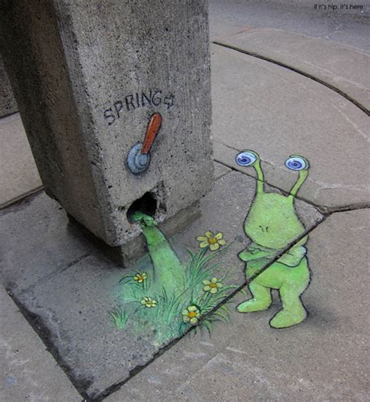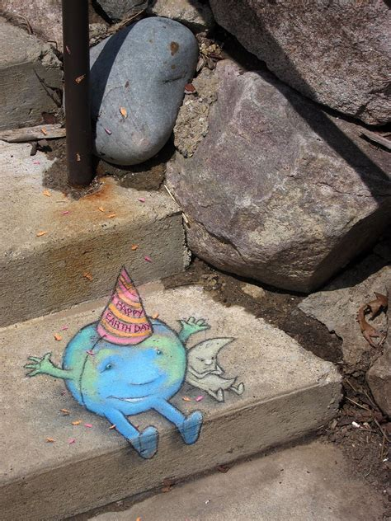- Using the video above from the chalk artist, David Zinn, do your best to recreate ONE of the images included below using **children’s** **chalk**. You can re-create the image of your choice on the sidewalk or driveway. This is the first experience you will have to be hands on with art in this class and what I want you to take from this activity is a simple fact a lot of us do not acknowledge: **making art is hard**.

- Please **take a picture of your finished product and email that to me as an attachment (DO NOT SHARE IT ON GOOGLE DRIVE)** when you have completed BOTH of these tasks.